BMS Document Information:

|  |  |
| --- | --- |
| BMS Document Number: | 4T01 |
| BMS Document Title: | Marketing Requirements Document Template |
| BMS Document Type: | Template |
| BMS Usage Requirement: | Optional |
| BMS Document Owner: | Dietmar Tandler |
| BMS Document Completed by: | Klaus Coenning |
| BMS Document Revision: | 1.0  Revision number is reverted back to Version 1.0 to align with the new Product Development Policy BMS SharePoint site created as part of the Simplification Initiative. |
| Date Document Completed: | 27-Aug-2014 |

**Instructions for Using this Record Template**

This template, when completed, will become a Record as outlined in Sections 4.2.3 and 4.2.4 of the TL9000 Quality Management System Requirements Handbook, Release 5.0.

When using this template

* Do not change the BMS Template Information (this page).
* Update the template on starting on Page 1.
* Control of records is outlined in Sections 4.2.3 and 4.2.4 of The TL9000 Quality Management System Requirements Handbook, Release 5.0.
* Populate Detailed Record Revision History and Footer information to reflect record revision and date.
* Released versions of the record should begin with Version 1.0.
* Use BMS Styles for formatting headers, body text, bullets and numbering.
* Rename document (e.g. RCATS Release 9.8 MRD, Revision 1.0).
* Delete Red text as it is instructions on how to complete the record.

Marketing Requirements Document

for NSA, RtSA, and NR TM

Record Revision History

| Rev | Date | Editor(s) | Description of change |
| --- | --- | --- | --- |
| 3.0 | 15-Oct-19 | Jin-Ook Kim | Adding the TM requirements |
|  |  |  |  |
|  |  |  |  |
|  |  |  |  |
|  |  |  |  |
|  |  |  |  |
|  |  |  |  |
|  |  |  |  |
|  |  |  |  |

Table of Contents

Contents

1 Process map 3

2 Purpose 3

3 Scope 3

4 Audience 3

5 Definitions 4

6 References 4

7 Roles and Responsibilities 4

8 Value Proposition 4

9 Description of Users 4

10 Use Case 5

10.1 Interfernece Hunting over CPRI interface 5

11 Requirements 5

11.1 RtSA POI 5

11.2 NSA mode 5

12 Market Windows 10

12.1 NSA (5G and LTE) 10

12.2 RtSA POI 10

# Process map

Project Plan

Design & Implementation

PDP

Tech. Doc.

System Architecture

Verification & Validation

System  
Integration

Software

Hardware

FPGA

Mechanical

Requirements

PLM

Operations

Service

Marketing

# Purpose

Purpose of this document is to specify the requirements for 5G NR NSA test capability and enhancement target of POI of RtSA.

# Scope

This project is applied to CA5000-F002 model in terms of hardware modification but can be applied to all CA5G product family in terms of software feature.

# Audience

This document is targeted for the following functions/teams:

* R&D
* NPI
* Operation
* Service & TAC
* Tech Pub

# Definitions

|  |  |
| --- | --- |
| **Term** | **Definition** |
|  |  |
|  |  |
|  |  |
|  |  |
|  |  |
|  |  |
|  |  |
|  |  |
|  |  |
|  |  |

# References

# Roles and Responsibilities

* R&D: Yoo-Chul Shin, Wei Chen, Sang-Gu Kang , Sang-Young Jung, Jae-Yong Park, Hyuck-In Kim, Nick G.
* QA: YongSung Jun
* PLM: JaeGab Lee, Eduardo, Reza Vaez Ghaemi
* GTM: Kashif Hussein, Jennifer Faircloth
* PMO: Jace Kim
* Tech Pub: Jay Kim
* Service: Su-Hee Park
* Ops: Pyeong-Soo Kim, Young-In Kim
* Sales: Joe Chou, Teressa Watts

# Value Proposition

* 5G NR launch in being made on NSA mode. Therefore, the market demand for a OTA solution that can cover both LTE and NR looks substantial.
* Especially for 5G NR operators on FR2 band, simple and cost effective antenna solution that can cover both FR1 and FR2 is highly demanded.

# Description of Users

Installation, Maintenance, and optimization engineers responsible for 5G NR NSA mode operation.

### 

# Use Case

# Requirements

## RtSA POI

### Definition

#### Enhancement of RtSA POI

### Requirements

#### POI Target

### License Policy

#### Free enhancement

## NSA mode

### Hardware modification

#### Direction of CA5G RF frontend modification is to add a supplemetary N-type port to allow CA5G can receive RF signal under 6 GHz through a separate antenna while the main k-type port is receiving mm Wave signal on FR2 band through a mm Wave antenna.

#### Two possible examples. R&D to choose the best direction to get reliability of new hardware and also can secure the effeciency of hardware upgrade from CA5000-f002.

### 5G NR - NSA OTA Analyzer overview

#### Key functions are the same with current NR OTA

##### Carrier Scanner

##### Signal Analyzer

##### Route Map

#### NSA OTA supports two operation mode, e.g. Fast and Normal.

#### NSA OTA supports extended mode that shows multiple PCI with associated signal information.

#### Functional Map

|  |  |  |  |
| --- | --- | --- | --- |
| Operation Mode | Carrier Scanner | Signal Analyzer | Routemap |
| Fast | Primary PCI and RSRP of each carrier | Primary PCI, RSRP, and Beam index (NR) | Route map with fast mode Carrier Scanner or Signal Analyzer |
| Normal | ++ Channel Power, Time Error, Freq Error, RS EVM (for LTE), and PBCH EVM (for NR) | ++  NR: SINR and RSRQ, multi Beam index of multi PCI  LTE: ID Scanner or OTA Control | Route map with normal mode carrier scanner or Signal analyzer |
| Pop-up | PCI Scanner | PCI Scanner | Not supported |

#### 

#### Number of carriers: User can confiure up to 8 carriers

##### Typical use case for NSA operation is to configure 2x LTE are for the control plane and 1x NR carrier for data plane.

##### In the future, NR on FR1 band can be used for control plane in addition to or on behalf of the LTE control plane.

##### Carrier Aggregation on NR will involves more NR data carriers. Therefore, the number of configurable NR carrier shall be expanded.

### Carrier Scanner

#### Definition

##### Carrier Scanner provides information that helps to identify the coverage of each BS by showing dominant PCI and RSRP.

#### Operation

|  |  |
| --- | --- |
| Operation Mode | Carrier Scanner |
| Fast | Primary PCI and RSRP of each carrier |
| Normal | ++ Channel Power, Time Error, Freq Error, RS EVM (for LTE), and PBCH EVM (for NR) |

#### 

##### Fast Mode

###### Carrier scanner shows the strongest PCI of each carrier regardless of technology.

###### Scan Time per carrier should not longer than 300 ms.

##### Normal Mode

###### It provides additional parameters shown on the above table

###### Enable Magnifier for each carriers

###### Scan Time per carrier should not longer than 600 ms.

##### Pop-up

###### Magnifier pops up beam analyzer for NR and ID Scanner for LTE

###### User can pop-up an additional window showing multi PCI staus of each carrier, or all at once (if applicable)

###### 

##### Support Data logging

### SIgnal Analyzer

#### Definition

##### Signal Analyzer provides information that helps to identify the beam coverage and signal quality with reliability.

#### Operation

|  |  |
| --- | --- |
| Operation Mode | Signal Analyzer |
| Fast | Primary PCI, RSRP, and Beam index (NR) |
| Normal | ++  NR: SINR and RSRQ, multi Beam index of multi PCI  LTE: ID Scanner or OTA Control |

#### 

##### Fast Mode

###### Primary PCI and RSRP for LTE Carrier

###### Primary PCI, RSRP, and beam index for NR Carrier

###### Scan Time per carrier should not longer than 600 ms.

##### Normal Mode

###### For 5G NR Signal, it shows Beam Analyzer screen that shows 8 strongest beams from any of available PCI (multi PIC)

###### For LTE, it shows ID Scanner screen or Control Channel selectively

##### Pop-up

###### User can pop-up a window showing multi PCI staus of each carrier or all at once.

#### GUI

##### Fast mode shows whole information on a single chart.

##### Normal mode consists of multiple charts. Please refer to the preferable combination of charts.

###### 2x LTE + 1x NR (FR2) scenario

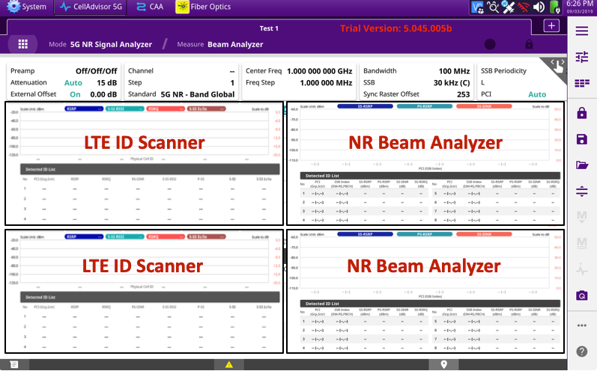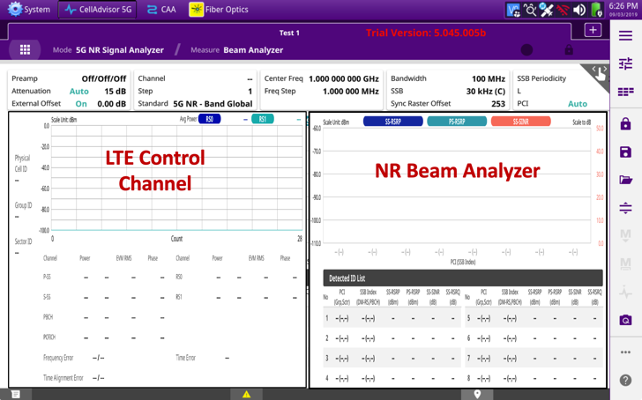

###### 1x LTE + 1x NR (FR2) scenario

###### 2x LTE + 2x NR (FR2) scenario

###### 1x NR (FR1) + 1x NR (FR2) scenario

##### User can configure the number of chart to show on the screens

##### Should support Data logging

##### 

### NSA OTA Route Map

#### Definition

##### Route Map works with both Carrier Scanner and Signal Analyzer.

##### Support Fast and Normal mode

##### Multi PCI is supported only when it is running Signal Analyzer with Normal mode

#### Operation

|  |  |
| --- | --- |
| Operation Mode | Routemap |
| Fast | Route map with fast mode Carrier Scanner or Signal Analyzer |
| Normal | Route map with normal mode carrier scanner or SIgnal analyzer |

#### 

##### User can choose one of the above mode to diplay the result on the map.

## Test Mode

### What is the TMs

### 3GPP identifies test signals for test cases. 3GPP defined the test models for 5G NR gNB transmitter testings in TS38.141 for confirmance testings.

### General requirements

#### The reference 3GPP documentation should be 2019-09 for TS38.104 and 141

#### FDD and TDD should be supported together

#### Following test cases should be supported in FR1 and FR2 bands

##### BS output power

##### Unwanted emissions

###### Occupied BW

###### ACLR

###### Operating band unwanted Emissions

###### Spurious Emissions

##### Signal Quality

###### Transmitt ON/Off power

###### Time alignment Error

###### Frequency Error

###### EVM for QPSK, 16QAM, 64QAM and 256QAM

#### BS output power, Occupied BW, ACLR, operating band unwanted emissions and spurious mission should be have spectrum waveform

#### Transmitt ON/Off power should have PvsT trace

#### EVM should be have the constellation diagram

#### TM analyzer should have an auto trigger spectrum analyzer for TDD

#### The results of each test cases should be met the 3GPP recommendation spec boundary.

#### Following test models and test cases should be supported in FR1 and FR2 bands

#### 

#### 

### License: this is new SW options feature (option #TBD)

# Market Windows

## NSA (5G and LTE)

* Alpha availability: 16-Dec-2019
* Beta availability: 09-Mar-2020
* FCS availability: 27-Mar-2020

## RtSA POI

* FCS availability: 27-Mar-2020

## TM

* Pre-Alpah availability: 16-Dec-2019
* FCS availability: 27-Mar-2020